Prerequisites

phpMyAdmin requires PHP v7.13 or newer and supports MySQL/MariaDB v5.5 or newer.

In this guide, I will use PHP 7.3 for phpMyAdmin.

Install MySQL / MariaDB Server

Before installing phpMyAdmin, install a database instance on your system to connect. You could install it as a standalone database or install as part of the [LAMP stack](https://www.itzgeek.com/tag/lamp).

Install the database and then required packages shown below.

Standalone Database

**READ:** [How To Install MariaDB on CentOS 7 / RHEL 7](https://www.itzgeek.com/how-tos/linux/debian/how-to-install-mariadb-on-debian-10.html)

yum install -y https://rpms.remirepo.net/enterprise/remi-release-7.rpm

yum install --enablerepo=remi-php73 -y httpd php php-cli php-mysqlnd

LAMP Stack

**READ:** [How To Install LAMP Stack on CentOS 7 / RHEL 7](https://www.itzgeek.com/how-tos/linux/centos-how-tos/configure-lamp-on-centos-7-rhel-7.html)

Install phpMyAdmin

phpMyAdmin is available in EPEL. So, install EPEL repository rpm to configure EPEL repository on your system.

rpm -Uvh https://dl.fedoraproject.org/pub/epel/epel-release-latest-7.noarch.rpm

Install phpMyAdmin using the following command.

yum install -y --enablerepo=remi-php73 phpmyadmin

Configure phpMyAdmin

phpMyAdmin places the configuration files in /etc/httpd/conf.d directory. It has rules and permission for the access.

By default, phpMyAdmin can be accessed only from the localhost. To access phpMyadmin from external machines, we have to edit the phpMyAdmin.conf file.

vi /etc/httpd/conf.d/phpMyAdmin.conf

In CentOS 7, web access is managed by the mod_authz_core.c module. So, the allow or deny rules won’t work even if you modify.

Default config will look like below.

# phpMyAdmin - Web based MySQL browser written in php

#

# Allows only localhost by default

#

# But allowing phpMyAdmin to anyone other than localhost should be considered

# dangerous unless properly secured by SSL

Alias /phpMyAdmin /usr/share/phpMyAdmin

Alias /phpmyadmin /usr/share/phpMyAdmin

<Directory /usr/share/phpMyAdmin/>

AddDefaultCharset UTF-8

<IfModule mod_authz_core.c>

# Apache 2.4

<RequireAny>

Require ip 127.0.0.1

Require ip ::1

</RequireAny>

</IfModule>

<IfModule !mod_authz_core.c>

# Apache 2.2

Order Deny,Allow

Deny from All

Allow from 127.0.0.1

Allow from ::1

</IfModule>

</Directory>

<Directory /usr/share/phpMyAdmin/setup/>

<IfModule mod_authz_core.c>

# Apache 2.4

<RequireAny>

Require ip 127.0.0.1

Require ip ::1

</RequireAny>

</IfModule>

<IfModule !mod_authz_core.c>

# Apache 2.2

Order Deny,Allow

Deny from All

Allow from 127.0.0.1

Allow from ::1

</IfModule>

</Directory>

Please comment out Require ip 127.0.0.1 and Require ip ::1 then add Require all granted just below to commented line. The content will look like below after the modification.

# phpMyAdmin - Web based MySQL browser written in php

#

# Allows only localhost by default

#

# But allowing phpMyAdmin to anyone other than localhost should be considered

# dangerous unless properly secured by SSL

Alias /phpMyAdmin /usr/share/phpMyAdmin

Alias /phpmyadmin /usr/share/phpMyAdmin

<Directory /usr/share/phpMyAdmin/>

AddDefaultCharset UTF-8

<IfModule mod_authz_core.c>

# Apache 2.4

<RequireAny>

**# Require ip 127.0.0.1**

**# Require ip ::1**

**Require all granted**

</RequireAny>

</IfModule>

<IfModule !mod_authz_core.c>

# Apache 2.2

Order Deny,Allow

Deny from All

Allow from 127.0.0.1

Allow from ::1

</IfModule>

</Directory>

<Directory /usr/share/phpMyAdmin/setup/>

<IfModule mod_authz_core.c>

# Apache 2.4

<RequireAny>

**# Require ip 127.0.0.1**

**# Require ip ::1**

**Require all granted**

</RequireAny>

</IfModule>

<IfModule !mod_authz_core.c>

# Apache 2.2

Order Deny,Allow

Deny from All

Allow from 127.0.0.1

Allow from ::1

</IfModule>

</Directory>

Restart the Apache service.

ADVERTISEMENT

systemctl restart httpd

Firewall

Configure the firewall to allow HTTP requests from external networks.

firewall-cmd --permanent --add-service=http

firewall-cmd --reload

Access phpMyAdmin

Now access the phpMyAdmin from the browser, URL will be:

http://localhost/phpMyAdmin

**OR**

http://your-ip-address/phpMyAdmin

**Login with the root (DB admin) or any database user.**

[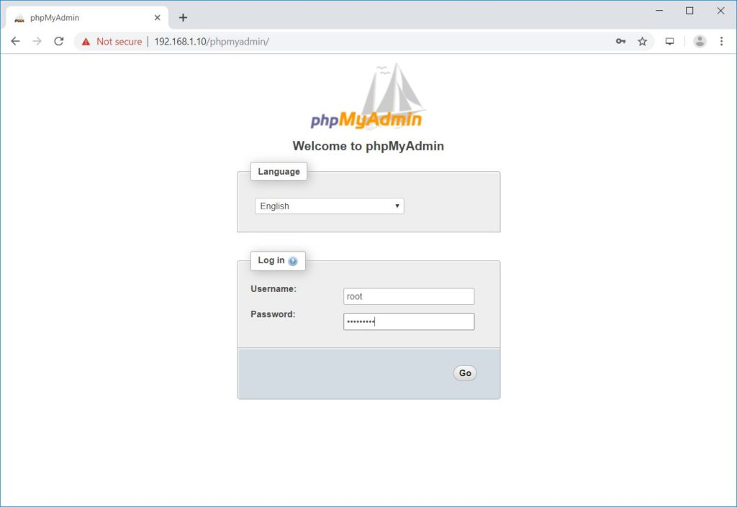](https://www.itzgeek.com/wp-content/uploads/2019/08/Install-phpMyAdmin-with-Apache-on-CentOS-7-phpMyAdmin-Login-Screen.jpg)Install phpMyAdmin with Apache on CentOS 7 – phpMyAdmin Login Screen

You will get the database page.

[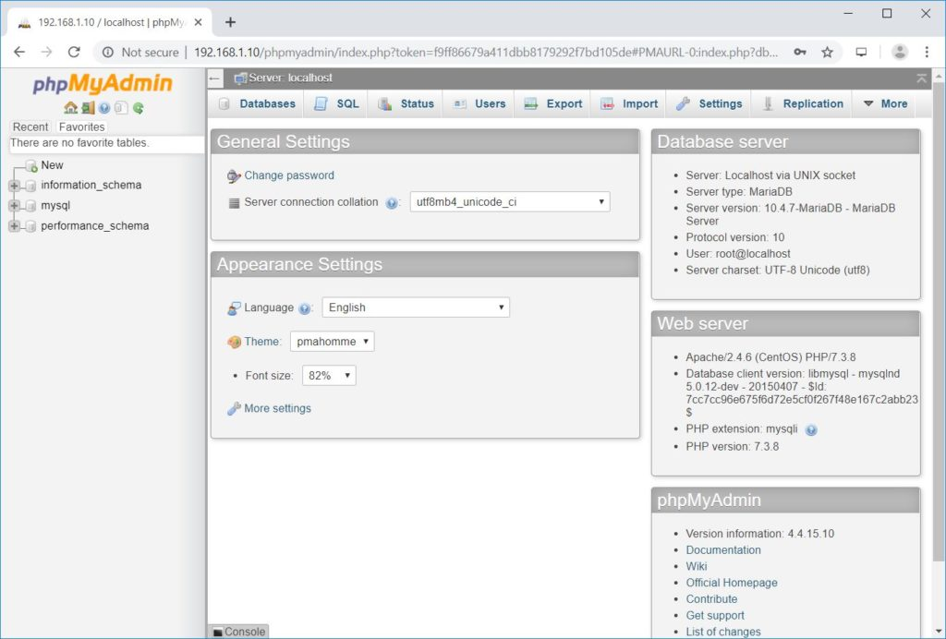](https://www.itzgeek.com/wp-content/uploads/2019/08/Install-phpMyAdmin-with-Apache-on-CentOS-7-phpMyAdmin.jpg)Install phpMyAdmin with Apache on CentOS 7 – phpMyAdmin